Open lesson plan
Unit: 7 Fantasy world | School: general secondary school №48
Teacher’s name: | А, Amanova
Date: | 21.02.2024
Grade: 5Ә | Number present: absent:
Theme of the lesson: | Places in a town
Learning objectives(s) that this lesson is contributing to: | 5.2.4.1 understand the main points of supported extended talk on a range of general and curricular topics;  5.3.5.1 keep interaction going in basic exchanges on a growing range of general and curricular topics;
Lesson objectives: | Learners will be able to:  -learn vocabulary for places in a town.  -ask and answer questions about my favourite place in town
Value links | Family – Family values are moral and ethical principles of typical family life, including sacrificing for loved ones, putting your loved ones first, and keeping your loved ones at the centre of your thoughts and actions.
Plan:
Part of the lesson/Time | Teacher’s activity |  |  | Student’s activity | Assessment |  | Resources
Beginning of the lesson  3 min. | 1. Greeting.  2. Organization moment.  3. Warm up  Dodocahedron  Students say wishes to each other  Divide students into 2 groups using pictures “Parents” and “Grandparents” ( students choose the leaders of their groups)  In differentiation part «Flexible pace learning» method was used to give students a choice in order to make them interested in learning process. |  |  | Students answer the questions  Creating a psychological atmosphere by wishing each other wishes  The aim: To develop Ss speaking skills and create friendly atmosphere  Efficiency: By wishing each other wishes they feel better and feel the support of others. | At the organization moment T tries to award active Ss. «The praise» method is used to evaluate Ss with phrases like:  “Good job!  Well done!” |  | Dodocahedron    Pictures of mothers, fathers, grandmothers and grandphathers  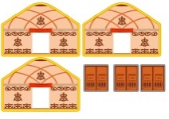
Pre-learning  «Brainstorming» method  4 min  3 min | Checking up homework with method of “Check your neighbor”  Pair work  WB p.48 Exercise -5  Match the underlined words in Text B with their meanings  Ss give their possible answers.  Lead – In  Watch the video  Teacher asks to students  1.What are you saw in this video? What are they?  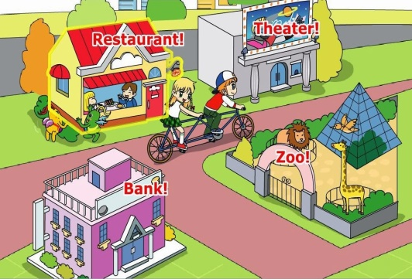 |  |  | Aim: Revise the previous lessons material.  Efficiency: Ss refresh their mind before starting new theme.  Students in pairs check each other’s work  Students will watch the video and will find theme of the new lesson  Students answer the questions  They are places in a city or town? | Students assess each other according to descriptor  Individual assessment  Total: 1 points  Individual assessment  Total 1 points |  | Whiteboard  Students Book  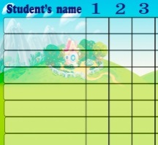  Internet resources  Presentation  Whiteboard  Watch a video
Middle of the lesson  7 min  6 min | After that T introduces the aim and theme of the lesson.  Lead in  Ex: 1 P: 69  • Ask students to open their books at page 69. Students describe what the people in the photos are doing, e.g. watching a football game, looking at bags. Then they work in pairs to do the matching exercise.  Play the recording.  Students listen to it and check their answers.  Play the recording again for students to repeat the words. Pay particular attention to the pronunciation of museum which is /mju:'zrəm/ rather than /mju:'zerǝm/. |  |  | Students listen to the teacher  Pupils match the pictures with the places in the box. Then listen, check and repeat.  ANSWERS  the sports center isn't in the photo  1 museum  2 shopping center  3 sports stadium  4 cinema  5 skate park  6 bowling alley  7 market | Descriptor:  - match the pictures with the places  - listen, check and repeat.  Self assessment  Total: 2 point |  | Whiteboard  Listen to the audio CD
 | Ex: 2 SB P: 69  • Play the recording.  Students identify the sounds and match them with the places ex-1  Students compare answers in pairs before you check answers with the class.  Differentiation:  Do task by supporting by partner.  Refreshment moment  Double double |  |  | Group work  Pupils listen to the sounds and match them with the places in the picture.  ANSWERS  1 sports stadium, 2 cinema, 3 shopping center, 4-bowling alley, 5 museum, 6 market, 7 skate park | Descriptor:  - listen to the sounds  - match them with the places  Total: 2 point |  | Whiteboard  Listen to the audio CD  Students Book  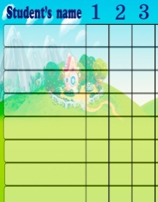
10 min | Reading task.  WB p.49 Ex-3  While reading task  Complete the text with places from Exercise-1. Work with a group to putting letters in order.  Differentiation:  Read text supporting by teacher.  Descriptor:  -arrange paragraphs correctly  Descriptor:  -complete the sentences  -use vocabulary |  |  | Students work in groups.  Students read the sentences and complete them with vocabulary.  1-cinema, 2-market, 3- shopping center, 4-sports centre, 5- skate park, 6- museum. | Group assessment  Total  2 points |  | Dao  Whiteboard  
End of the lesson.  10 min | Ex: 3 P: 69  • Read out each of the four questions in the chart and write your own answers to them on the board. Write notes rather than full sentences, e.g. every Saturday, with my friends, go to the cinema.  Give students a couple of minutes to copy and complete the chart with their own information.  Conclusion during the lesson some tasks differentiated by outcomes of the students and by their abilities |  |  | Pupils copy and complete the table with information about you.  ANSWERS  Students own answer  Differentiation: «Conclusion» method is used to finish the lesson. | Ss evaluate each other and encourage classmate with phrases like:  Well done! Brilliant! Good job! I like it!  Total  2 points |  | Whiteboard  Handouts
End of the lesson.  2 min | FEEDBACK  Learners give their feedback with “Asyk” Home task: WB p.49 Ex-2. |  |  |  |  |  | Poster Success
Additional information
Differentiation – how do you plan to give more support? How do you plan to challenge the more able learners? |  | Assessment – how are you planning to check students’ learning? |  |  |  | Health and safety check  ICT links
- Students support each other.  - More capable students will be given more challenging material to work with in order to allow them to be more challenged.  - The students will be supported by the teacher during independent work. |  | - The teacher and students will give brief feedback.  - Peer assessment  - Group assessment |  |  |  | ICT
Reflection  Were the lesson objectives/learning objectives realistic? Did all learners achieve the LO?  If not, why?  Did my planned differentiation work well?  Did I stick to timings?  What changes did I make from my plan and why? |  |  | Use the space below to reflect on your lesson. Answer the most relevant questions from the box on the left about your lesson.
Summary evaluation

What two things went really well (consider both teaching and learning)?
1:
2:
What two things would have improved the lesson (consider both teaching and learning)?
1:
2:
What have I learned from the lesson about the class or individuals that will inform my next lesson?

